## **01 User Roles Written Report**

## Images

Figure 1

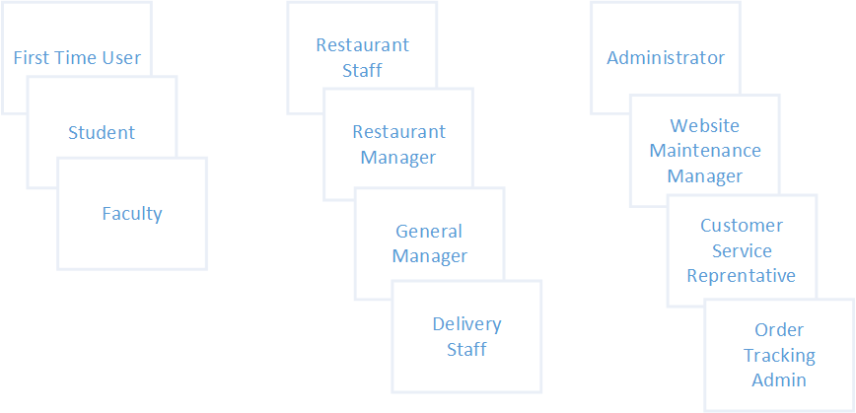

Figure 2

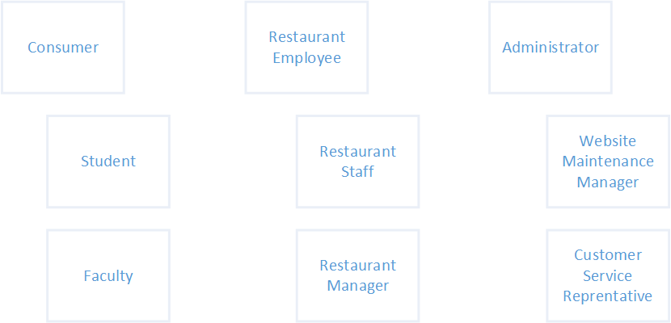

## Discussions

According to our discussion, we removed first time user from the consumer group and delivery staff from restaurant employee group. Keep in mind that consumer, restaurant employee, and administrator are just groups titles that we categorized user roles under.

Reason to remove first time user is because visitors are not familiar with the food suppliers in Centennial. They might have no idea where to pick up the food. In addition, registering will take even longer time compared to order food at the counter. Last but not least, visitors often do not have the situation where they only have 10 minutes break between two classes to buy food. We keep student and faculty as two types of users based on the faculty will be allowed to use promo codes to get discounts on their orders.

Reason to remove deliver staff is because we found there are both technical and business issues. From technical point of view, it is hard to locate the consumer precisely in the building. Even though we can use classrooms to identify the location, students will move from one place to another during the break. From business point of view, hiring deliver staff is also extra cost. Delivering food to the classroom directly also interrupts the lecture. We keep restaurant staff because they need to update the order status after student or faculty pick up the food. The restaurant manager will take care of the total available food amount and update based on the inventory. General Manager oversees the information across all the restaurants.

In terms of admin, we think its responsibility shall be separate into three parts. Website maintenance manager takes care of the website functionalities. Customer service manager is in charge of customer complaints and other services. Order tracking admin will track KPIs for each order such as the average wait time.

## Details

Details of each role:

Student:

Will use this app very often. They are considered as major users of this app. They are very familiar with computers and apps, and open to new technologies, Students have high level of expertise within their domain. Their goal is after convenience with good experience as well. Students will use this application to order from a restaurant of their choice from Centennial college.

Faculty:

Will use this app often. They are the second largest group of users. They are well educated and have very high levels in their domain. Their goal is after convenience mainly. Faculty have the same roles as the students and will use this application for ordering purposes.

Restaurant staff:

Will use this app very often. Most of them are as same age as students. Willing to embrace the new technology. Require low level of expertise in their domain with CenEats. Their goal is after convenience like how to process the order efficiently. Restaurant staff will use this application to view customer orders from the CenEats and confirm that the order is ready.

Restaurant Manager:

Sometimes use this app to check or update inventory status if a certain item runs out of stock. They may use this app at a relative low level of proficiency. Restaurant Manager has low level of expertise within their domain, while the General Manager contain a medium level of expertise. Their goal is after convenience. Restaurant Manager will report all their inventory stock problems to the General Manager in charge of all restaurants using CenEats, the General Manager is responsible for updating the inventory status on CenEats

Website Maintenance Manager:

Will use this app very often. They will monitor the daily status of the website. They have a very high level of proficiency and expertise in their domain. Website Maintenance Manager desire a rich experience using this application as their role is to keep the system up and running at all time.

Customer Service Rep:

Will use this app with high frequency to deal with customer complaints and order tracking problems. They have a medium high level of proficiency and expertise in their domain to use this app. Their goal is after convenience but also desire a rich experience in order to monitor the CenEats daily of any issues or complaints. Customer Service Representative is responsible for dealing with customer complaints and issues that are reported in the review section of CenEats, while Order Tracking Admin is responsible for keeping track of all order issues that may occur on the application.